mazvita monalisa muguti

CLDV6211 POE PART 2

St10094577

Mazvita M Muguti

CLDV6211 POE PART 2

QUERY NUMBER 5

Write a query that will return all the rentals placed between the following dates “2021-08- 01” AND “2021-10-30”

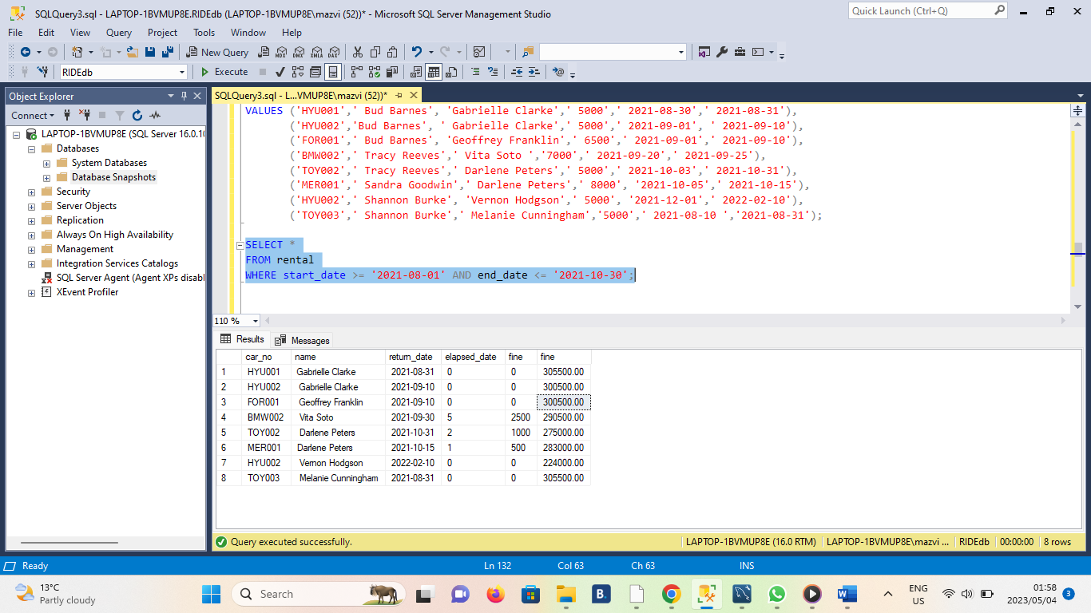

QUERY NUMBER 6

Write a query that selects all the rentals placed by Bud Barnes.

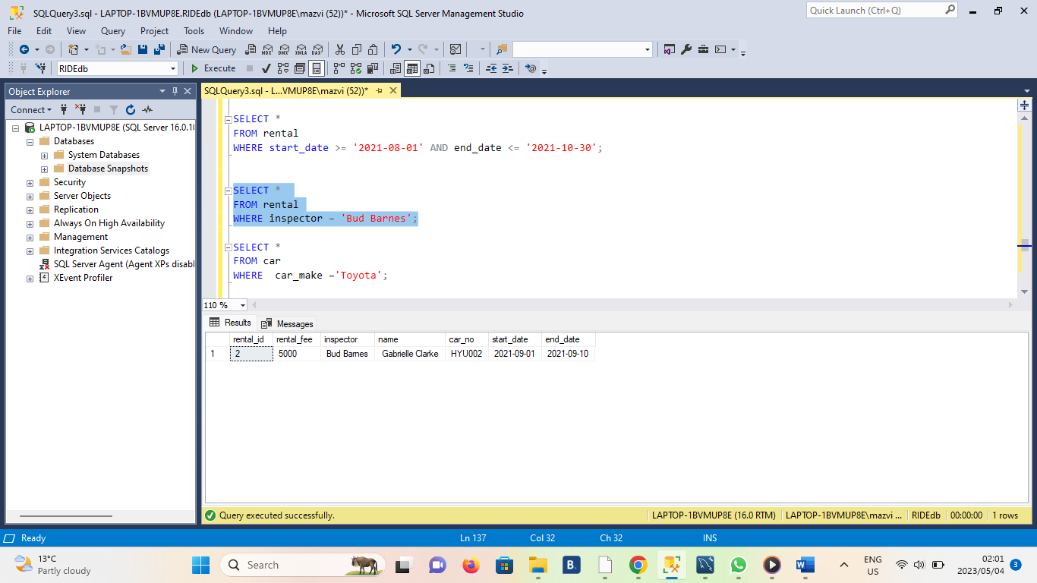

QUERY 7

Write a query that displays all the returns for the car make Toyota.

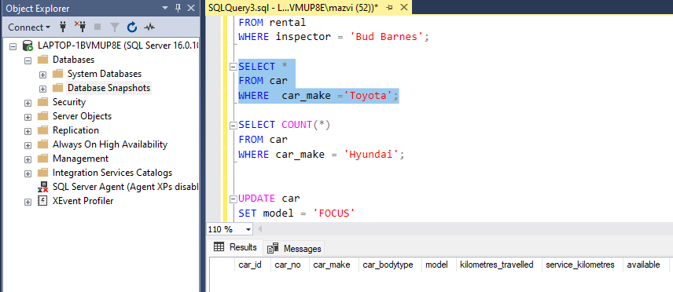

QUERY 8

Write a query that counts the number of rentals that were placed for the car make Hyundai.

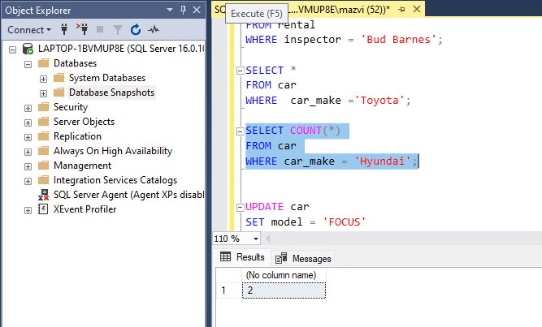

QUERY 9

9. Write a query to update the Model of the car with the CarNo FOR001 from “Fiesta” to “Focus”

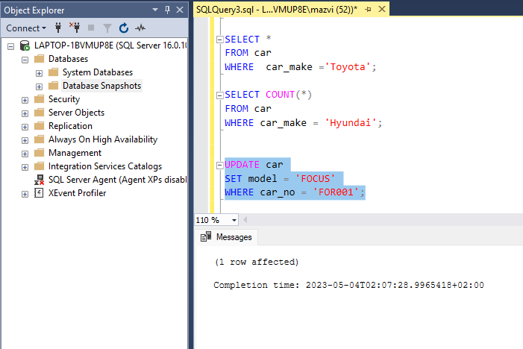

QUERY 10

Write a query that will display the CarNo, Driver Name, Rental Fee, Start Date, End Date and Availability of all available rentals.

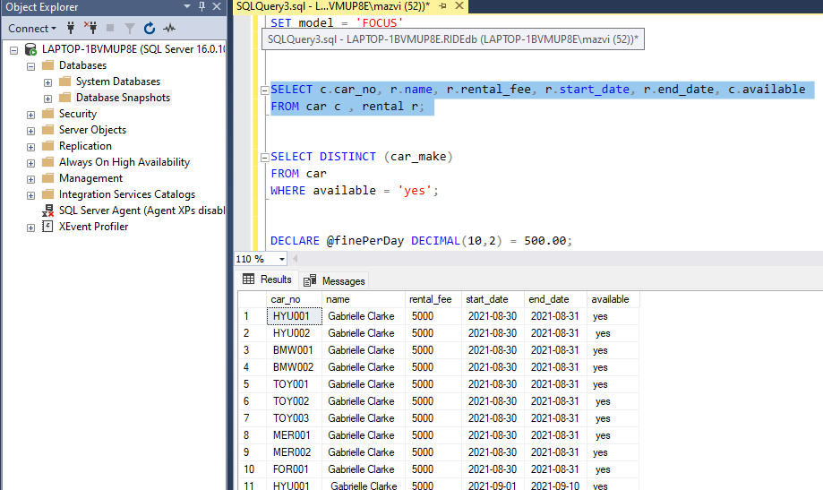

QUERY 11

Write a query that will show a list of the available car makes in the database use the DISTINCT command.

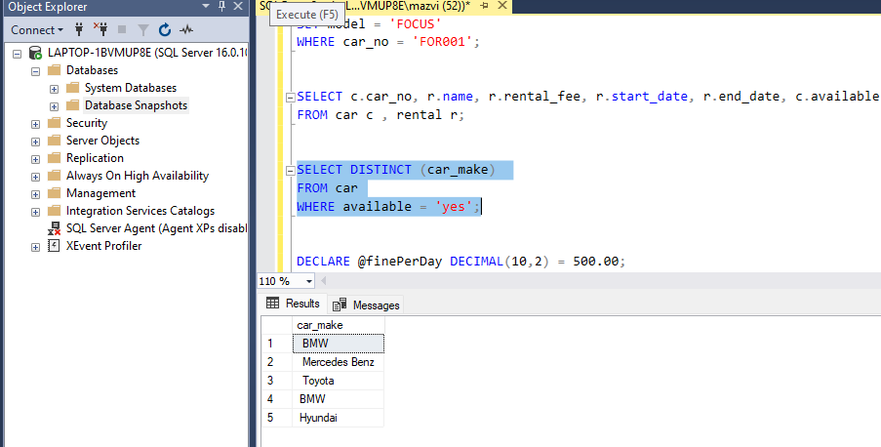

QUERY 12

Write a query that will determine the cars which will need service soon. If a car’s kilometres travelled is 9000 kilometres away from the service kilometres that would indicate that the car would need to get a service soon.

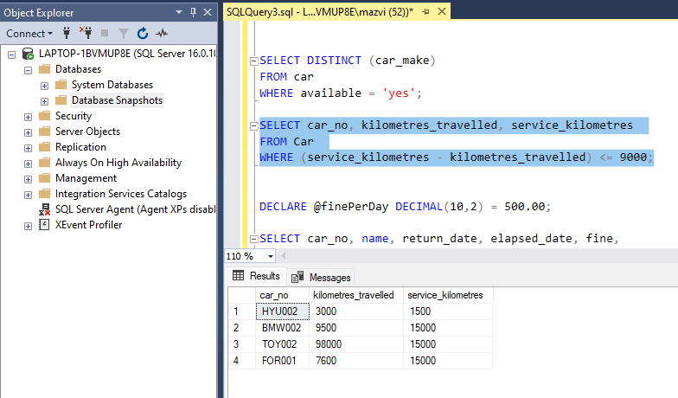

QUERY 13

Write a query that will calculate the late fee for a return (a R500 a day fine is placed on rentals returned passed the elapsed return date. The query should use the return date and the current/Today’s date to calculate the elapsed number of days and multiply those days by the R500 fine to get the total fine).

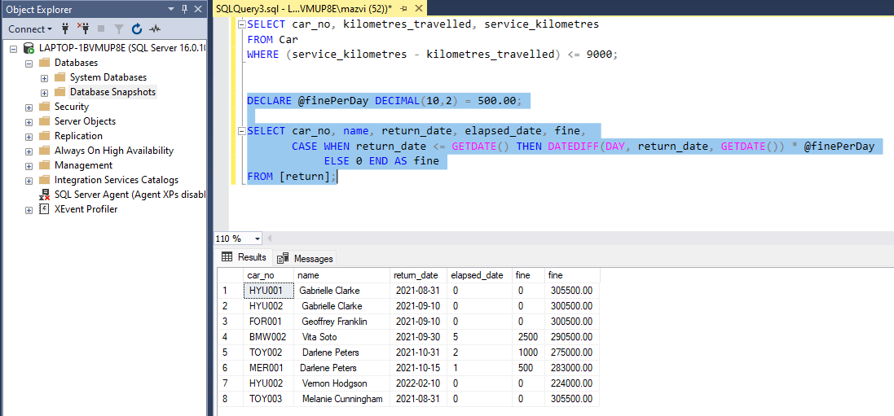

Take a screenshot of the connection to your MS Azure SQL Server (shown in your local SSMS) with at least one table result called back as a query.

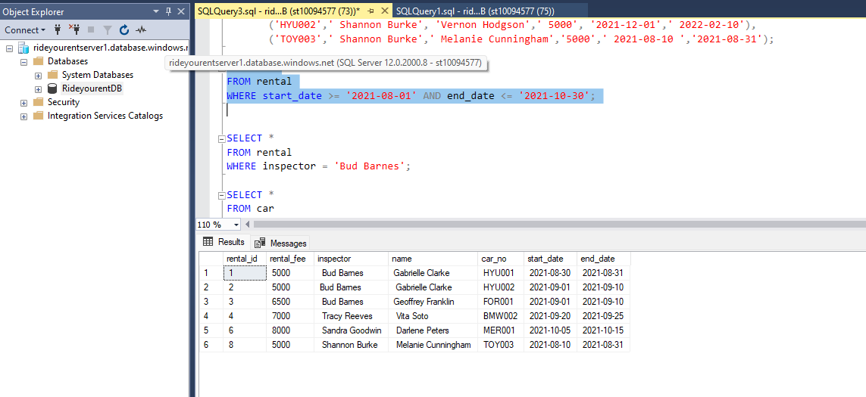

Take a second screenshot from the Azure Query Editor to demonstrate that data shows up in the query editor on Microsoft Azure (do this for the same table used for the first screenshot)

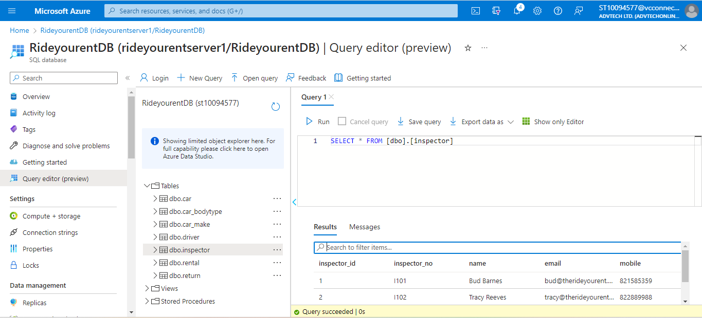

References

w3schools. (2023, April 29). *w3schools*. Retrieved from w3schools: https://www.w3schools.com/mysql/mysql_count_avg_sum.asp

W3schools. (2023, April 28). *w3schools*. Retrieved from W3schools: https://www.w3schools.com/mysql/mysql_insert.asp

w3shools. (2023, April 29). *w3schools*. Retrieved from w3schools: https://www.w3schools.com/mysql/mysql_update.asp